COMMUNITY ENGAGEMENT PROJECT COMMUNITY COMPOSTING MANAGEMENT
BACHELOR OF SCIENCE (INFORMATION TECHNOLOGY)
SEMESTER V
By

Asmi Mayekar
Roll Number: 2430C0022
Under the esteemed guidance of

Rohini Desai, Assistant Professor,
Department of Computing


DEPARTMENT OF COMPUTING
VIDYALANKAR SCHOOL OF INFORMATION TECHNOLOGY
(Autonomous College affiliated to University of Mumbai) MUMBAI, 400037
MAHARASHTRA 2026 - 2027

VIDYALANKAR SCHOOL OF INFORMATION TECHNOLOGY
(Autonomous College affiliated to University of Mumbai) MUMBAI-MAHARASHTRA-400037 DEPARTMENT OF COMPUTING

CERTIFICATE
I hereby certify that Ms. Asmi Mayekar (Roll Number: 24302C0022), Student of Vidyalankar School of Information Technology, studying in T.Y. B.Sc. (Information Technology) Semester V has completed a C.E.P project titled “Community composting management” at “My green society” during the academic year 2026-27.

Internal Guide Head of Department
Department of Computing

Internal Examiner External Examiner


Date: Principal

Organization Visit Observation Sheet
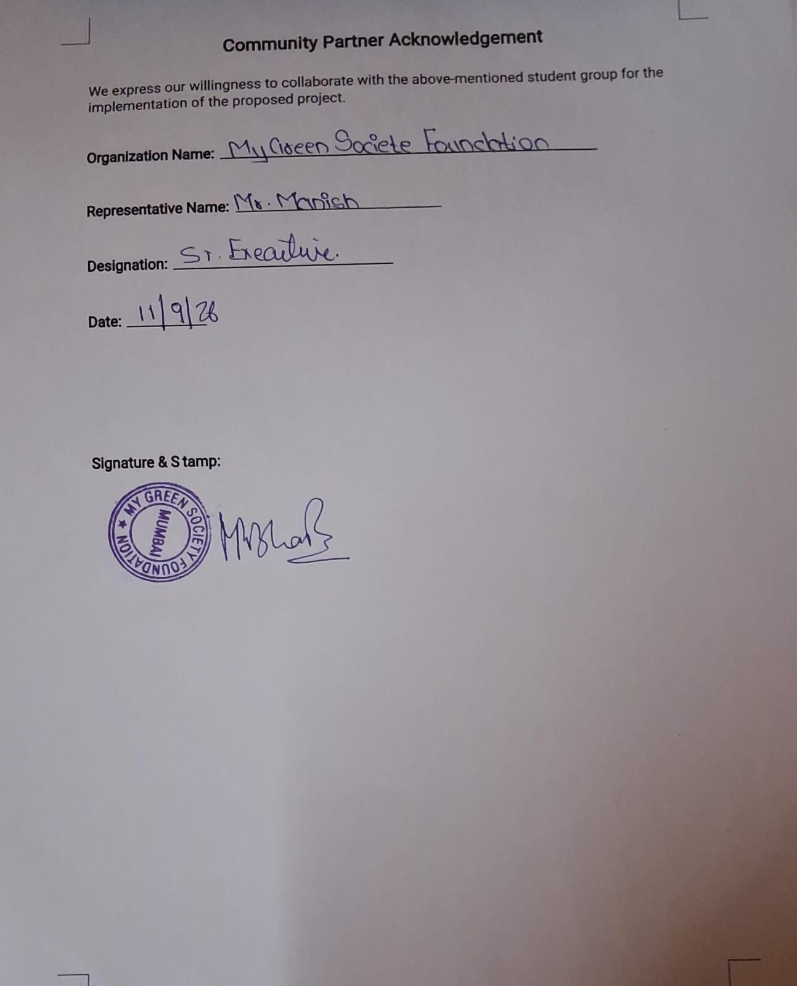

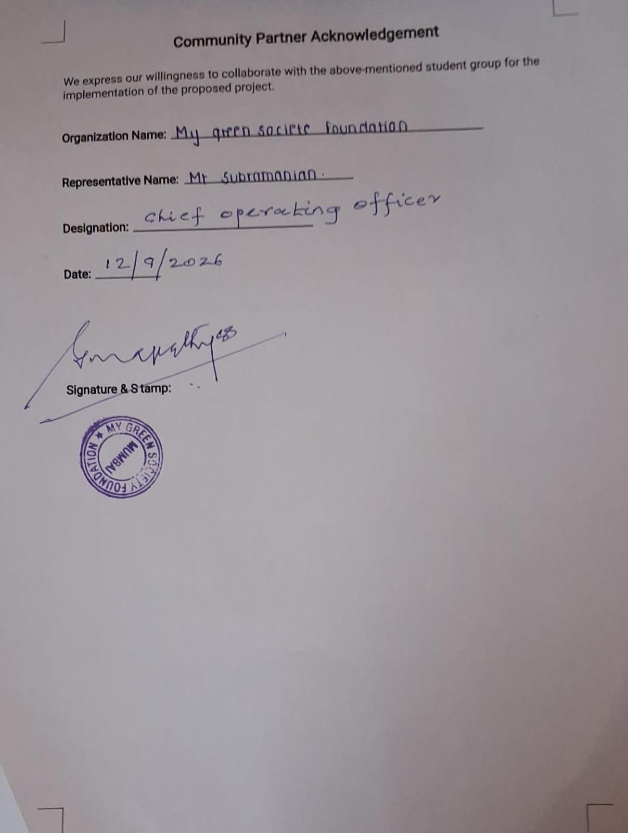

Project Guide Meeting Record
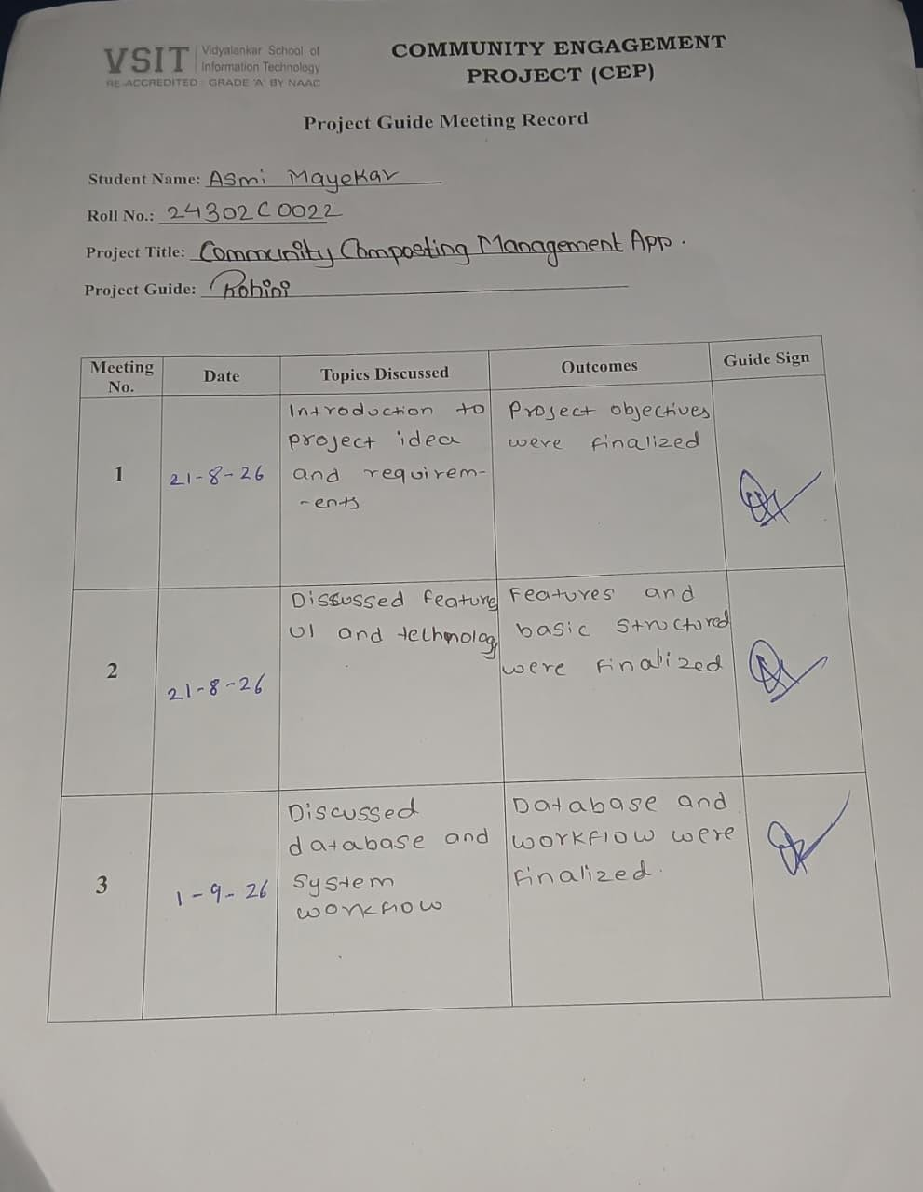

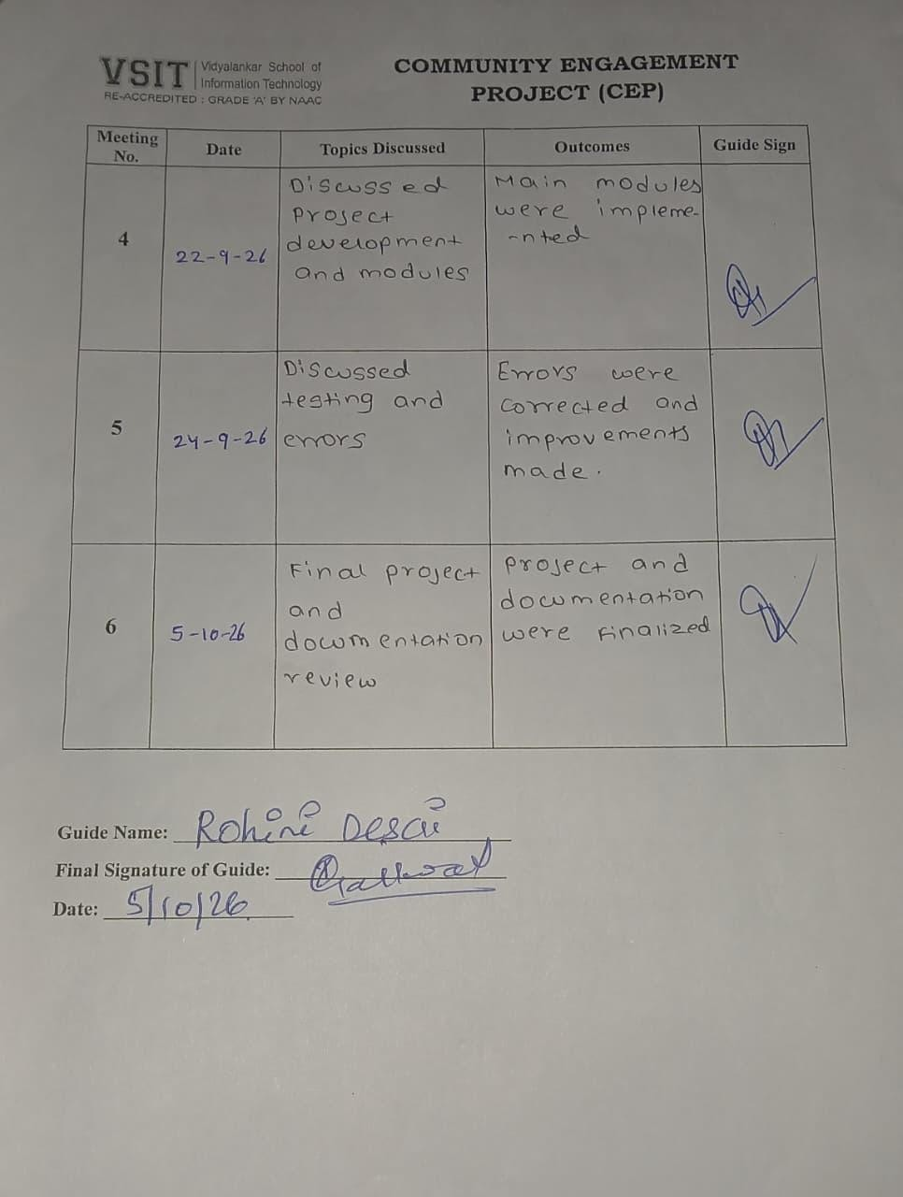

DECLARATION

I, Ms. Asmi Mayekar student of Vidyalankar School of Information Technology, studying in T.Y. B.Sc. in Information Technology, hereby declare that I have completed the C.E.P project entitled “Community Composting Management App” during the academic year 2026-27
The information presented in this report has been collected through interactions, observations, interviews, surveys, organizational records, and project activities undertaken during the field visits.
Due credit is extended on the work of Literature/Secondary Survey by endorsing it in the Bibliography as per prescribed format.

Signature of the Student with Date

Name of Student

ACKNOWLEDGEMENT

We express our sincere gratitude to the University of Mumbai and Vidyalankar School of Information Technology for providing us an opportunity to undertake this Community Engagement Project.
We extend our heartfelt thanks to our Faculty Mentor, Ms. Rohini Desai, for her constant guidance, encouragement, and constructive feedback, which greatly helped us in completing this project successfully.
We are equally grateful to My Green Society for granting us the opportunity to visit and work on the project. The support and cooperation received from the staff members gave us meaningful exposure and helped us connect our academic knowledge with the available Sustainable Development Goal (SDG 11,12 and 13).
Lastly, we wish to thank our peers and faculty members for their support and motivation, which made this project a collaborative and enriching experience.

ABSTRACT

This Community Engagement Project was carried out with My Green Society, a Mumbai-based environmental non-profit organisation that works on waste segregation, composting, beach clean-ups and public awareness. During field visits to the organisation’s office in Andheri East, Mumbai, it was observed that community waste management involves several connected activities, namely segregation at source, scheduled collection, composting, record-keeping and communication, which require close coordination between residents, collection workers and NGO administrators. The objective of the project was to design a digital solution that brings these activities onto a single platform. Requirements were gathered through direct observation, interaction with the organisation’s staff, prepared interview questions, group discussion and review of available organisational and secondary material. They were supported by a literature review of reports from the World Bank and the United Nations Environment Programme, the United Nations Sustainable Development Goals and India’s Solid Waste Management Rules, 2026. The proposed solution is the Community Composting Management App, a mobile application with role-based access for residents, workers and administrators. It provides user registration and profiles, collection schedules, assigned routes, pickup status updates, composting-unit records, waste and compost tracking, push notifications, reports and analytics, Green Points, educational guides, and a help and support centre. The application uses Flutter for the user interface, Firebase for authentication, database and notifications, cloud storage for files, and Google Maps for routes and locations. The key outcome is a complete requirement analysis, system design and implementation plan for a centralised system that makes waste and compost activities easier to schedule, monitor and report. For the organisation, the app supports organised record-keeping and clear visibility of operations. For the community, it encourages segregation and composting through reminders, learning material and rewards. The project contributes to SDG 11, SDG 12 and SDG 13.

TABLE OF CONTENT

CHAPTER 1: INTRODUCTION 11
  - Project Background 11
  - Problem Statement 11
  - Need for the Project 11
  - Objectives 11
  - Scope 11
  - SDG Alignment 12
CHAPTER 2: REQUIREMENT ANALYSIS AND LITERATURE REVIEW 13
  - Methodology Adopted 13
  - Stakeholder Interactions 13
  - Domain Overview 13
  - Existing Process Analysis 13
  - Existing Solutions and Related Work 13
  - Technologies Studied 13
  - Research Gap and Need for Proposed Solution 14
  - Challenges Identified 14
CHAPTER 3: PROPOSED SOLUTION 15
  - Solution Overview 15
  - System Architecture 15
  - Process Flow Diagram 15
  - Module Description 15
  - Advantages of Proposed Solution 15
CHAPTER 4: SYSTEM DESIGN 16
  - System Design Overview 16
  - Use Case Diagram 16
  - Workflow Diagram 16
  - Module Design 16
CHAPTER 5: PROJECT IMPLEMENTATION 17
  - Development Methodology 17
  - Module-wise Implementation 17
  - User Interface Solution 17
  - Screenshots of Developed Solution 17
CHAPTER 6: TESTING AND VALIDATION 18
  - Test Cases 18
  - Test Results 18
  - User Acceptance Testing 18
  - Feedback from Stakeholders 18
  - Performance Evaluation 18
CHAPTER 7: RESULTS AND IMPACT ASSESSMENT 19
  - Deliverables Submitted 19
  - Results Achieved 19
  - Impact on Organization 19
  - SDG Contribution 19
CHAPTER 8: CONCLUSION AND FUTURE SCOPE 20
  - Conclusion 20
  - Key Findings 20
  - Recommendations 20
  - Future Enhancements 20
REFERENCES 21
Research Papers 21
Books Referred 21
Website 21
Annexures (Highly Recommended) 22
- Annexures A 23
- Annexures B 24
- Annexures C 25
- Annexures D 26
- Annexures E 27
- Annexures F 28
- Annexures G 29

TABLE OF FIGURES
Figure 3: Proposed System Architecture 9

Figure 4: Proposed Process Flow 10

Figure 4.2 case diagram 13

Figure 4.3 workflow 13

Figure 4.4 workflow 14

Figure 7.0 and 7.1 19

Figure 7.5 19

Figure 0.1 24

Figure 0.2 25

Figure 0.3 29

Figure 0.4 30

CHAPTER 1: INTRODUCTION

Project Background
My green society is an environmental nonprofit organisation based in Mumbai dedicated to sustainability and ecofriendly practises. The organisation actively engages communities in environmental Conservation through initiatives such as beach cleanups, waste segregation network, public awareness campaigns and community composting programme.
Building upon the organisation’s real-world impact, this project introduces the Community Composting Management App- A digital solution designed to stream Local waste management The platform supports the entire operational workflow, from household waste segregation and collections to community composting centres, compost tracking, and final distribution or use.

Problem Statement
Community waste management involves different groups of people working together, including residents’ collection workers, composting operators, and an administrator. When schedules, collection logs, composting updates, complaints, reminders, and reports are handled separately or manually, it becomes hard to coordinate and keep track of everything. Without a single platform, residents may struggle to find collection times, workers may it difficult to manage their assigned pickups, and administrators miss out on a clear overview of total waste collected and compost produced to solve this issue, the project purpose a centralized application to organize all these activities smoothly and improve communication among everyone involved.

Need for the Project
A digital community composting of us and organ Pay to record and monitor all- management Tasks full It reduces reliance on scattered paperwork makes Collection Schedules Simple to check, sends timely reminders and gives administrators a clear single view of community participation and composting. The proposed system also motivates residents To Involved by offering features like contribution tracking, green points, status reports, notifications, and educational resources. Overall, this system helps achieve the main goal of keeping Waste out of Landfills and encouraging Effective compost at the community level.

Objectives
The main goal of this project is to build a digital tool that handles community sorting, collection, composting, tracking, communication, and overall user participation.
    - Primary Objectives
      - Enables registration and profile for residents, collection, and administrators.
      - Allow residents to easily check the waste-collection timetables and receive reminders.
      - Help workers view their assigned routes and update collection statuses in real time.
      - Keep accurate records of community composting units, including their capacity and current status.

      - Monitor the total amount of waste collected and compost produced across the community system.
      - Provide administers with detailed reports, analytics, announcement, and user management features.

    - Second Objectives
      - Promote responsible waste sorting and active community involvement.
      - Offers a simple way for users to report collections or service problems.
      - Introduce Green points and rewards to recognize active participation.
      - Share educational resources and tips on composting and sustainability.
      - Plan for future needs by supporting multilingual will use and low-connectivity environments.

Scope
The project scope covers the design and planned development of a mobile-based Community Composting Management App Featuring Role-based access for residents, workers, and admin or NGO users. The system includes user registration and profiles, collection timetables, assigned routes, status updates, for pickups, composting unit records, tracking for wasted and composting unit records, tracking for waste and compost, push notifications, reports, green points, educational guides, and a help/support centre. The proposed technology stack features Flutter, Firebase, cloud storage, and Google Maps. However, the project does not aim to automate physical waste collection or mechanical composting machinery; instead, it focuses purely on digital coordination, tracking, record-keeping, and boosting community engagement.

SDG Alignment
The project slowly collects with sustainable development goal 11 (Sustainable cities and communities Sustainable cities and communities) While promoting local waste management and cleaner neighbourhood Habits. It also supports SDG 12 (Responsible consumption and production) by encouraging Proper Waste Sorting, careful handling of organic waste, and composting. Additionally, SDG 13(Climate action) Is Addressed Because improved management Organic waste helps foster Sustainable environment Practises and awareness. The alignment is based on the intended Goals and feature off the Proposed App rather than claiming a formally measured SDG impact.

CHAPTER 2: REQUIREMENT ANALYSIS AND LITERATURE REVIEW

This chapter explains the requirement analysis and literature review carried out for the proposed Community Waste Management and Composting System. The requirements were identified through observation, field visits, stakeholder analysis, secondary research, and the study of existing environmental management practices. The chapter also discusses the importance of community waste management, the limitations of traditional manual processes, the technologies considered for application development, and the need for an integrated digital platform.

Methodology Adopted

The project followed an observation-based and requirement-analysis approach to understand the problems associated with community waste management and composting. The main purpose of this methodology was to identify the needs of different users and develop a system that could improve waste collection, composting activities, communication, and record management.

The first step involved studying the organization's background and understanding its environmental activities. Publicly available information and secondary sources were considered to understand waste segregation, organic waste processing, composting methods, and digital waste-management solutions.

The second step involved observing the general waste-management workflow, including household waste segregation, waste collection, transportation, and processing of organic waste. The next step was to identify the requirements of residents, collection workers, composting operators, and administrators.

After identifying the requirements, the complete process was divided into different application modules. These modules included user management, collection schedules, pickup status updates, issue reporting, composting-unit monitoring, notifications, and report generation.

Finally, the proposed system was evaluated through functional testing scenarios to check whether its major features could perform the intended tasks. This methodology helped establish a clear understanding of the project scope and provided a foundation for designing a practical and user-friendly application.

Stakeholder Interactions
Stakeholder analysis is an important part of requirement analysis because it helps identify the expectations of people who will use or manage the proposed system. In a community waste-management system, different users have different responsibilities and information needs.

    - Residents: Residents are responsible for separating organic and non-organic waste and following the community's collection schedule. They require access to collection timings, reminders, waste-segregation guidelines, and educational information. They should also be able to report missed pickups, incorrect collection, and other problems. A contribution-tracking feature can help residents understand their participation in community waste-management activities.
    - Waste-Collection Workers: Collection workers are responsible for collecting waste from assigned locations and updating the status of pickups. They need information about collection routes, scheduled pickups, and reported issues. The application can help them mark collections as completed, identify pending tasks, and communicate problems to administrators.
    - Composting Operators: Composting operators manage the organic waste received at composting units. They need to maintain records of incoming waste, monitor processing activities, update composting status, and record the quantity of finished compost. These features can improve record accuracy and support better monitoring of compost production.
    - Administrators: Administrators manage the overall functioning of the application. They require features for managing residents and workers, assigning collection duties, monitoring composting units, publishing announcements, and generating reports. An administrative dashboard can provide a consolidated view of collection activities, reported problems, and composting records.

Domain Overview
Effective community composting requires cooperation between residents, collection workers, composting operators, and administrators. Residents must separate waste correctly, collection workers must follow schedules, and composting operators must maintain suitable processing conditions. Administrators must coordinate these activities and maintain accurate records.

Community composting can provide several environmental benefits. It helps divert suitable organic waste from general waste-disposal streams, reduces the amount of biodegradable material sent to landfills, and produces compost that can be used to improve soil quality. Composting also supports awareness about responsible waste handling and sustainable living.

However, the success of these activities depends on regular monitoring, proper segregation, timely collection, and active public participation. A lack of coordination can lead to missed collections, incorrect records, and difficulties in monitoring compost production.

A digital platform can support the physical waste-management process by centralizing information and improving communication. Residents can view schedules and report problems, workers can update collection statuses, and administrators can monitor activities through a common system. Therefore, the proposed application aims to connect the major stages of community waste management in a simple and organized manner.

Existing Process Analysis
In a conventional community waste-management system, residents usually separate waste at home and place it at designated collection points. Collection workers collect the waste and transport suitable organic material to composting units. The composting operators process the material, while administrators maintain records and coordinate the activities.

Although this process can work effectively, managing it manually may create several difficulties.

First, collection schedules and announcements may be communicated through notices, telephone calls, messaging groups, or verbal instructions. This can result in confusion when schedules change or information does not reach every resident.

Second, paper-based records and separate spreadsheets may make it difficult to maintain accurate information about completed pickups, waste quantities, reported problems, and compost production. Finding previous records may also require additional time.

Third, residents may not have a convenient method to report missed collections or receive updates about their complaints. Workers may also experience difficulties in identifying assigned tasks and informing administrators about collection-related issues.

Another limitation is the lack of centralized monitoring. When collection information and composting records are maintained separately, administrators may find it difficult to understand the overall performance of the community waste-management process.

The proposed system addresses these limitations by introducing centralized records, role-based access, digital collection-status updates, notifications, issue reporting, and dashboards. It aims to improve coordination and information availability while reducing dependence on disconnected manual processes.

Existing Solutions and Related Work
    - Existing waste-management solutions generally focus on specific activities such as waste collection, recycling awareness, route planning, complaint registration, and waste tracking. These applications demonstrate how digital technologies can support environmental services and improve communication between service providers and users.
    - Collection-management systems can help organize pickup schedules and assign tasks to workers. Complaint-management systems allow users to report problems and monitor their status. Environmental-awareness platforms provide information about segregation, recycling, and responsible waste disposal.
    - Community composting initiatives, on the other hand, emphasize household participation, local processing of biodegradable waste, environmental education, and the use of finished compost in gardens and other suitable areas.
    - The proposed project brings these requirements together in one community-focused application. Its main objective is to connect residents, collection workers, composting operators, and administrators through a shared workflow. The application is designed to support both operational activities and environmental awareness.

Technologies Studied
The selection of suitable technologies is important for developing a reliable and maintainable application. The following technologies were considered for the proposed system.

Kotlin: Kotlin was considered for Android application development because it supports modern Android programming and allows developers to create structured, user-friendly mobile interfaces. It can be used to implement different screens and functions for residents, collection workers, composting operators, and administrators.

    - Firebase: Firebase was considered for authentication, database services, and backend-related functionality. Authentication can help manage user sign-in, while a suitable Firebase database can store and retrieve information such as user details, collection schedules, pickup statuses, complaints, and composting records. Real-time data synchronization may also support timely updates between users.
    - Cloud Storage: Cloud storage was considered for storing relevant documents, photographs, and other media files. For example, residents may attach photographs when reporting a waste-collection problem, subject to the application's storage and access rules.
    - Google Maps: Google Maps was considered for location-related functions and collection-route support. It can help display collection points and provide geographical information that may assist workers in navigating assigned areas.
    - Together, these technologies can support the development of an Android-based prototype with user authentication, structured data management, location-related features, and notifications. Their final implementation depends on the project's functional requirements, service configuration, security needs, and available resources.

Research Gap and Need for Proposed Solution
    - The requirement analysis identifies a need for better integration of the major activities involved in community waste management and composting. Many existing approaches focus on individual tasks, such as collection scheduling, complaint reporting, or environmental awareness, without necessarily connecting the entire waste-to-compost process.
    - A centralized application can address this gap by bringing residents, collection workers, composting operators, and administrators onto a common platform. It can provide collection schedules, pickup updates, issue reporting, composting records, announcements, and administrative reports.
    - The proposed solution also emphasizes transparency and participation. Residents can receive relevant information and report problems, while administrators can monitor recorded activities and identify areas requiring attention. Composting operators can maintain organized records of waste received and compost produced.
    - The main purpose of the proposed system is therefore not simply to digitize waste collection but to support the complete community waste-to-compost workflow. By improving coordination, record management, and access to information, the system aims to make community waste-management activities more organized and efficient.

Challenges Identified
Several challenges were identified during the requirement-analysis stage.

    - Accurate Record Management: Maintaining correct information about collections, waste quantities, complaints, and compost production is essential. Inaccurate or incomplete records may affect monitoring and reporting.
    - Waste Segregation: Residents may not always separate biodegradable and non-biodegradable waste correctly. The application can provide educational guides and reminders to encourage proper segregation.
    - Collection Coordination: Collection schedules may change because of operational difficulties, holidays, or other circumstances. Timely communication is necessary to prevent confusion and missed pickups.
    - Composting-Unit Monitoring: Composting operators need to update processing records regularly. Delayed updates may make it difficult for administrators to understand the current status of composting activities.
    - User Participation: Continuous participation is important for the success of community waste-management programmes. The application should be simple and accessible so that users can understand its functions and use them regularly.
    - Technical Challenges: The application must provide secure role-based access, reliable data storage, appropriate notification handling, and accurate location information. It should also be designed to work effectively under different network conditions.
    - User-Friendly Design: Residents, workers, operators, and administrators may have different levels of digital experience. Therefore, the interface should use clear labels, simple navigation, and easy-to-understand instructions.

In conclusion, the requirement analysis and literature review establish the need for an integrated digital platform for community waste management and composting. The proposed application combines essential functions into a single system and provides a foundation for improving collection coordination, composting records, communication, and environmental awareness.

CHAPTER 3: PROPOSED SOLUTION
This chapter describes the developed Community Composting Management App. This solution helps bring together the residents, workers for waste collection, and administrators for NGO in one role-based mobile platform. The process starts from home waste segregation to collection to composting.

Solution Overview
This application serves as a platform where residents can create their profiles and perform various actions, such as viewing collection schedules, reporting problems, tracking their contributions, setting reminders, earning green points and much more. Similarly, workers can check their collection routes, updates collection statuses, and report any issues. Administrators are responsible for managing all users and workers, overseeing composting unit information, monitoring waste and compost data, posting announcements, and viewing analytics.

System Architecture
This workflow shows how community composting works, step, by step. It starts with residents sorting their waste at home. Then the waste is. Taken to a composting site. There it’s turned into compost. The final compost is tracked to see how much is made and where it goes. This helps keep waste collection organized. It also encourages people to manage waste. It supports a healthier environment.

Figure 3: Proposed System Architecture

The architecture comprises four major layers: Presentation Layer, Application/Service Layer, Data Layer, and External Services. The mobile application display screen interfaces tailored to the respective roles of the users. Firebase provides authentication and backend or database services. Cloud storage is utilized for storing any required documents or media files. Google Maps handles collection routing and location-based features.

Process Flow Diagram
The Community Composting Management App gives one place for residents, waste collection workers and admins to work together. It helps with sorting waste planning collection times and keeping track of compost. This makes waste handling cleaner and more organized. The app also helps people in the community get involved and learn more about protecting the environment. It supports goals, like SDG 11 SDG 12 and SDG 13 by making cities better using resources wisely and cutting down on climate harm.
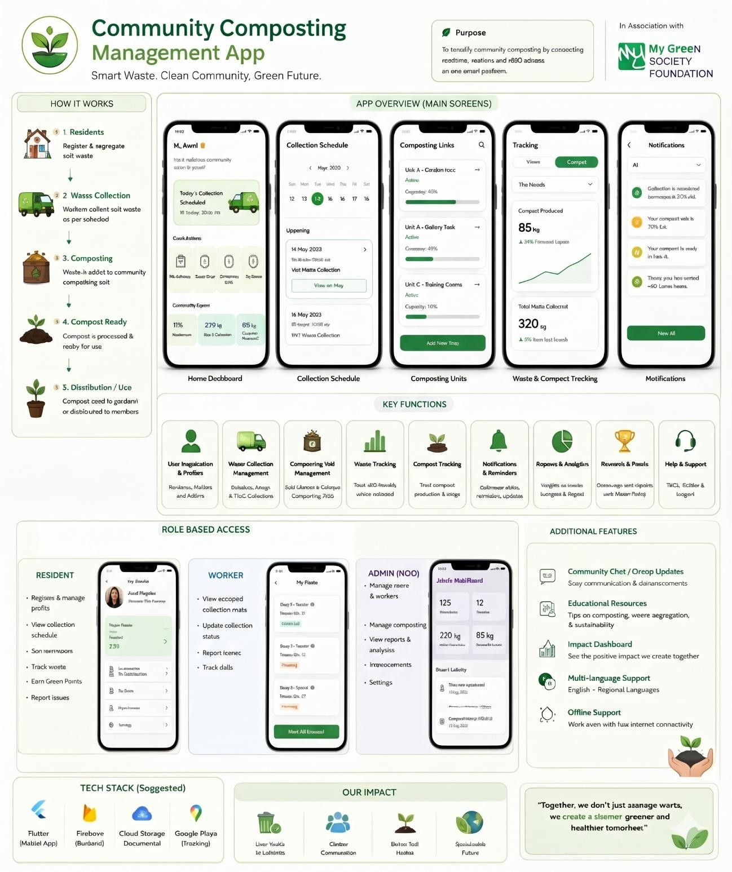
Figure 4: Proposed Process Flow

Module Description
The Community Composting Management App contains the following modules:

- Resident Module: This module is used by the residents for their registration and managing their profiles, viewing collection schedules, getting notifications, monitoring their waste contributions and reporting issues.
- Worker Module: This module is used by the waste collection workers for viewing assigned waste collection tasks, route information, updating collection status, and managing collection records.
- NGO Admin Module: This module is used by the NGO admin to manage the residents and workers, assign the collection schedules, manage composting units, waste records and generate reports.
- Collection Management Module: This module manages waste collection schedules, task assignments and pickups coordination for residents and workers.
- Composting Management Module: This module manages the information about composting units, organic waste processing and compost production.
- Waste Tracking and Reports Module: This module manages the waste contribution records and composting details.
- Notification and Support Module: This module provides collection reminders, announcements, issue reporting and communications between users and administrators.
- Awareness and Green Points Module: This module promotes environmental awareness through the provided educational resources and reward system for encouraging the community participation.

Benefits of Proposed Solution
    - Brings all community ware and composting data into one centralized platform.
    - Gives different stakeholders easy access to the information relevant to their roles.
    - Improves the transparency and tracking of the entire waste collection process.
    - Makes it easier to monitor composting site and track total compost production.
    - Supports timely notifications and provides a simple way to report service issues.
    - Encourages active participation through green points and helpful educational recourses.

Chapter 4: SYSTEM DESIGN
The system design maps out the requirements in terms of roles, modules, data entities, workflow, and user interface. It is done following a role-based system design approach to ensure that all stakeholders see only the functionality related to their respective roles.

System Design Overview
There are three major roles within the system: Residents, Workers, and Admin/NGO. Residents interact with collection schedules, personal contributions, issue reports, reward points, notifications, and customer support. Workers handle assigned collection tasks and updates their statuses, while administrators manage users, workers, composting units, system announcement, reports and overall settings.

Case diagram
The use case diagram clearly shows how residents, workers and NGO administrators interact with the Community Composting Management App. The use case diagram explains how residents, workers and NGO administrators register, view schedules, update collections and manage reports. The use case diagram also defines the functions of the Community Composting Management App and clarifies the responsibilities of each user role.

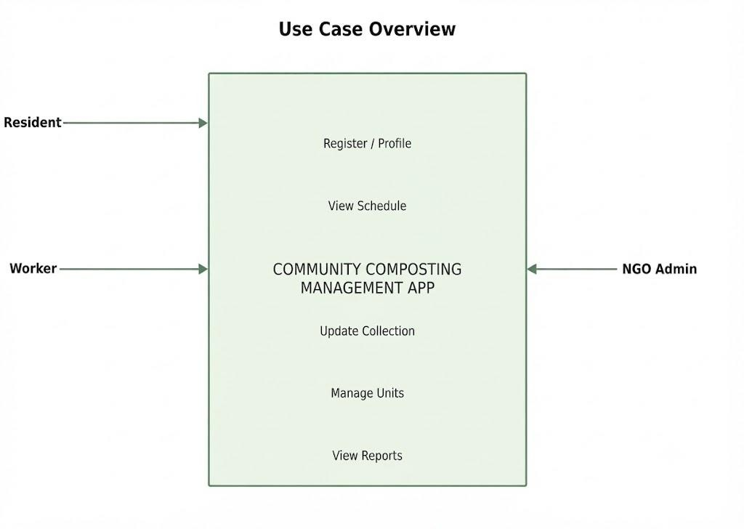

Figure 4.2 case diagram

Workflow diagram
    - Register accounts and properly segregate waste at the source.
    - View up-to-date local waste collection schedules.
    - Track and record waste successfully collected from households.
    - Send collected organic waste to the designated composting unit.
    - Log and monitor the active composting process.
    - Mark the organic compost as ready when fully processed.
    - Distribute and utilize the finished compost for gardening or other purposes.
    - Maintain complete oversight through tracking, automated notifications, and reports.

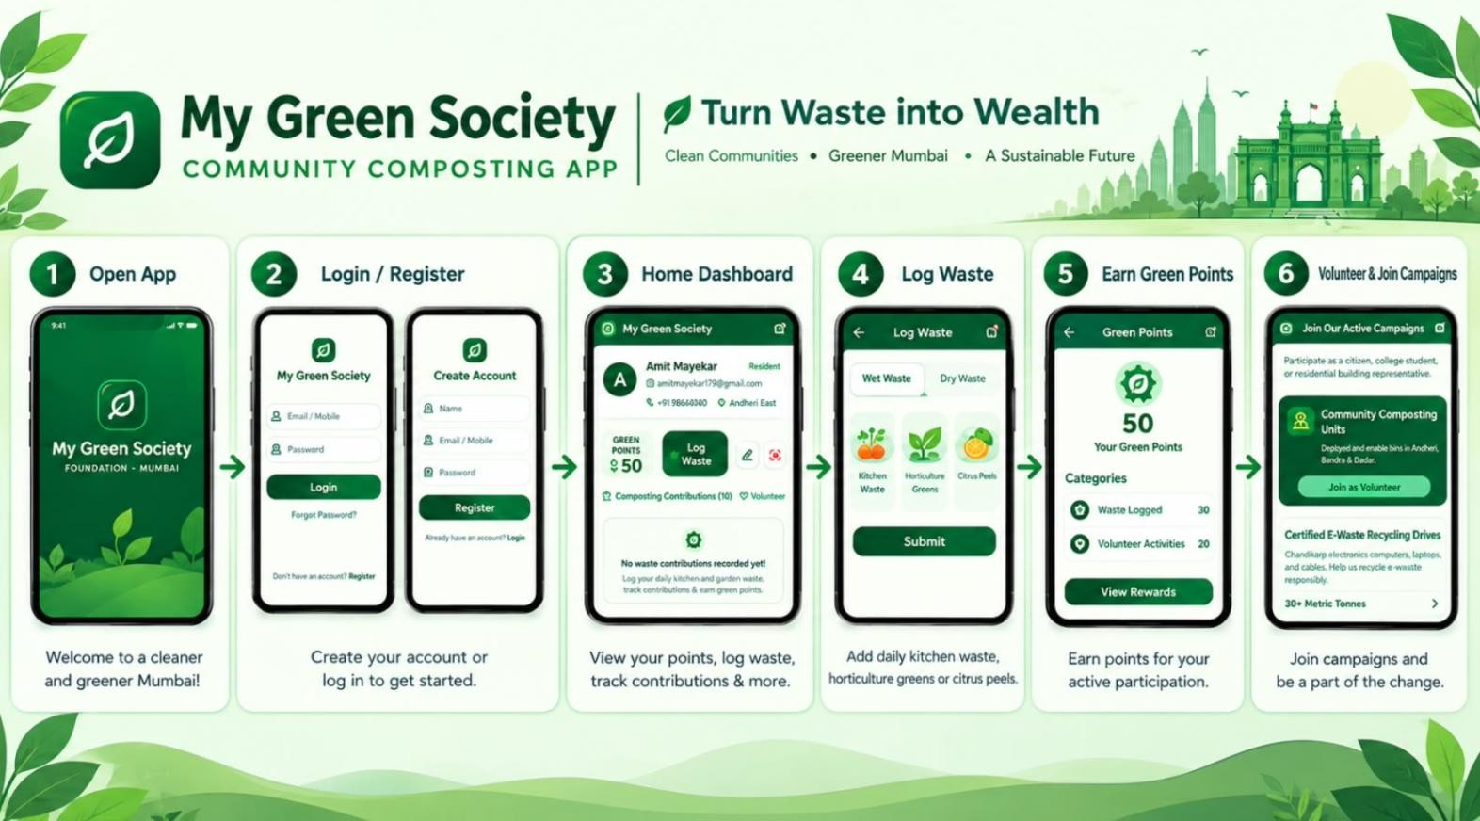
Figure 4.3 workflow

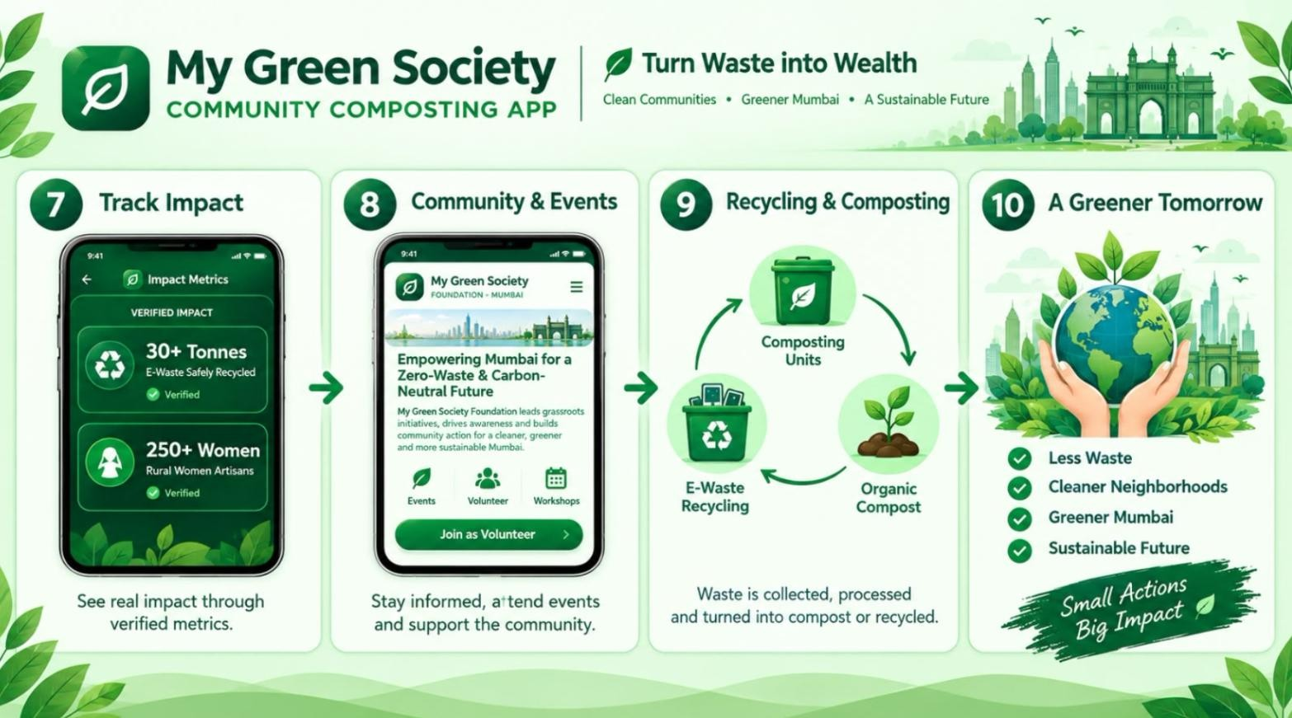

Module design
Figure 4.4 workflow

Module design relies on a shared data model where user details, collection timetable, work assignments, waste records, composting unit info, compost output, notifications, reports, and reward points are securely lined through proper identifiers. Role-based access control is applied at both the application interface level and the data access level. The system can easily be expanded in the future to support more communities, additional languages, advanced analytics, offline data synchronization, and more.

CHAPTER 5: PROJECT IMPLEMENTATION

The implementation plan follows an iterative development process. The project begins with requirement analysis and interface design, followed by database/service planning, module development, integration, testing, and refinement based on feedback.

Development Methodology
An incremental approach is proposed: first establishing user roles and authentication, followed by implementing collection scheduling, composting unit management, tracking, notifications, reporting, and support features. Each module is tested individually before being integrated into the main application.

Module-wise Implementation
User and role management secures access for residents, workers, and administrators. Collection management handles schedules and task assignments. Composting unit management tracks facility details and stats. Waste and compost tracking records quantities and trends. Notification and reporting modules ensure communication and visibility, while rewards, updates, and support boost engagement.

User Interface Solution
The proposed interface features a clean green-and-white visual theme that highlights the application’s environmental focus. Key screens include the home dashboard, collection schedule, composting units, tracking tools, and administrators. The design emphasizes straightforward navigation, readable information cards, clear status indicators, progress bars, and prominent action buttons.

Screenshots of Developed Solution
The project documentation outlines the proposed application overview and the core concept for role-based interfaces. These screen layouts illustrate the intended navigation flow and information architecture for the Community Composting Management App. Actual screenshots of the developed should be embedded into section once the final implementation is completed.

CHAPTER 6: TESTING AND VALIDATION

Testing and validation are required to verify that the proposed application behaves according to the identified requirements. Functional test cases focus on registration, role access, schedules, collection updates, composting-unit records, tracking, notifications, reporting, and issue reporting.

Test Cases
TC01 – Test resident sign-up with correct details. TC02 –Test login with valid and invalid password.
TC03 – Test if residents can see the collection schedules. TC04 – Test if workers can view assigned routes.
TC05 – Test if workers can update collection status TC06 – Test if admins can update composting units. TC07 – Test whether the records are saved and shown. TC08 – Test to check whether the records are logged. TC09 –Test for notification.
TC10 –Test for residents can report issues. TC11 – Test whether admins can view reports.
TC12 - Test if unauthorized users are blocked from restricted pages

Test Results
These tests check both correct and incorrect actions. Expected results include proper role access, accurate collection updates, correct waste and compost logs, working notifications, and blocked restricted pages. Final test results will be added after running the app.

User Acceptance Testing
User testing should involve real users from each role (Resident, worker, and admin). The evaluation will focus on easy navigation, clear info, helpful reminders, smooth collection steps, and useful reports.

Feedback from Stakeholders
Key feedback areas include a simple interface, clear reminders, quick issue reporting, accurate records, easy composting-unit status, and helpful educational content. Feedback from stakeholders during final checks should be logged in the attached feedback form.

Performance Evaluation
Performance can be measured through screen load times, passed test cases, data reliability, alert behavior, and usability. Since this is a proposed community app, big performance claims need real test data. This chapter shares the project results and its impact on the community. It was built for MY Green SOCIETY to give them structured digital platform for their environmental activities and goals.

CHAPTER 7: RESULTS AND IMPACT ASSESSMENT

This chapter presents the outcomes achieved through the development of the proposed Community Composting Management App and evaluates its potential impact on residents, waste collection workers, administrators, and the organization. The system was designed to simplify community waste management by connecting different stakeholders through a single digital platform.

Deliverables Submitted
The following deliverables were prepared as part of the project:
    - Community Composting Management App: A proposed digital tool to manage local waste collection and composting.
    - Resident Module: Features for sign up, schedule viewing, waste tracking, green points, reminders, and reporting issues.
    - Worker Module: Allows viewing routes, updating collection status, reporting issues, and saving daily collection logs.
    - Admin/NGO module: Tools for managing users, composting units, announcements, reports, and analytics data.
    - Waste Collection Management: Supports scheduling, assigning tasks, and keeping track of collected waste.
    - Composting Unit Management: Options to add, monitor, and maintain community composting unit details.
    - Waste and Compost Tracking: Let users monitor total waste collected and compost produces or used
    - Notification and Reminders: Sends collection alerts, schedule updates, and other important notices.
    - Reports and Analytics: Provides insights into waste collection, compost output and community participation.
    - Documentation: Complete notes covering project background, requirements, system design, testing and impact.
    - User Manual: Simple instruction explaining the features available for each user type.
    - Project Diagrams: Includes system architecture, process flows, use cases, workflows and module design.

Results Achieved
The project resulted in the design of an integrated platform for community waste and composting management. The major results achieved are:
    - A central platform connects residents, collection workers and administrators.
    - Waste collection activities are organized using schedules and reminders.
    - Community composting units are maintained through a dedicated module.
    - Collected waste and produced compost are recorded and track digitally.
    - Role-based access ensures users only see functions for their duties.
    - Residents view their waste activities and earn Green Points and rewards.
    - Workers manage assigned collection routes and update collection statuses.
    - Administrators control users, workers, composting units and reports.
    - Reports and analytics offer insights into waste and composting progress.
    - Educational resources and updates build awareness about waste and composting.
    - The system provides a structured digital way to manage community waste.

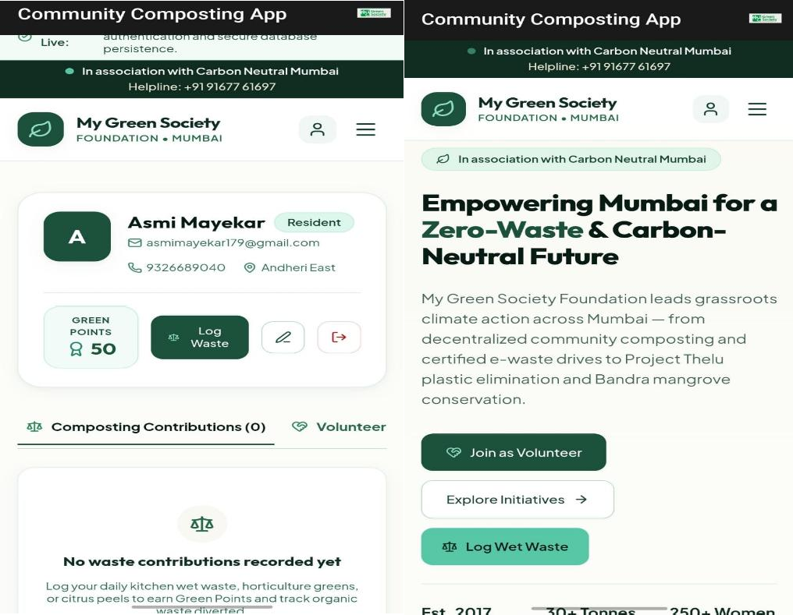

Figure 7.0 and 7.1

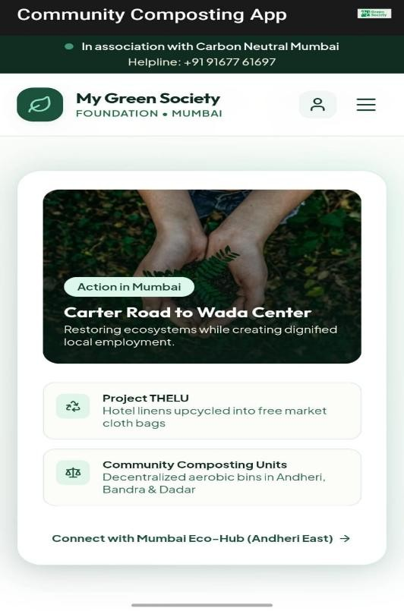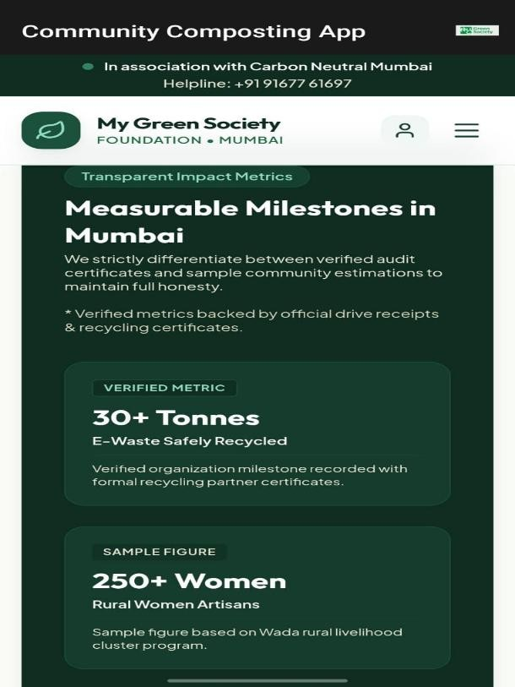
Figure 7.2 and 7.3

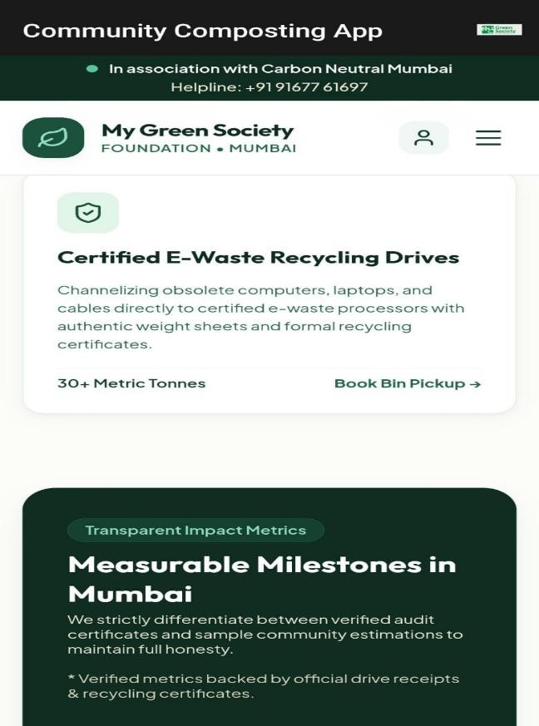
Figure 7.5

Impact on Organization
The proposed application can provide several benefits to the organization and the community:
- Improved Waste Management
The system organizes waste collection and keeps digital records, making the whole process much more structured.
- Better Coordination
Residents, workers and admins can connect on one shared platform instead of relying on separate, scattered communication methods.

CHAPTER 8: CONCLUSION AND FUTURE SCOPE

This chapter summarizes the overall project, highlights the major findings obtained during the study and development of the proposed Community Composting Management App, and presents recommendations and possible future enhancements.

Conclusion
The Community Composting Management App was proposed to make local waste collection and composting easier. It connects residents, workers, and NGO admins on one digital platform.
The system offers features like user sign-up, collection schedules, composting trackers, alert, analytics, rewards, and support. Its role-based design ensures everyone only accesses what they need.
The project improves waste coordination and monitoring. Bringing everything together supports organized management, boosts community involvement, and gives clear visibility into waste and compost tasks.
Overall project shows how a digital system supports sustainable waste practices, cleaner neighbourhoods, better waste use, and more awareness about composting.

Key Findings
The major findings identified during the project are:
    - Centralized Management: One platform connects residents, workers and admins to organize tasks.
    - Collection Scheduling: Schedules and reminders help residents known when waste is picked up.
    - Composting Monitoring: Tracking units’ status and capacity helps administrators manage facilities.
    - Waste and Compost Tracking: Recording waste and compost data provides insights into community efforts.
    - Role-Based Access: Separate interfaces for each user type keep the system organized.
    - Community Participation: Green Points and rewards motivate residents to manage waste responsibly.
    - Information and Awareness: Educational resources teach users about sorting waste and composting.

Recommendations
The following recommendations are suggested for the organization and future users:
    - Encourages Segregation: Remind residents to regularly sort wet and dry waste before pick-up.
    - Keep Schedules Updates: Ensures collection timetables are accurate for both residents and workers.
    - Monitor Composting Units: Regularly update the status and capacity of community composting facility.
    - Use Analytics: Review reports to track waste collection and compost output.
    - Share Educational Content: Provide regular tips on composting, waste sorting, and sustainability.
    - Boost Participation: Motivates residents using Green Points, rewards, and community events.
    - Offer Support: Give clear guidance for users who are new to digital apps.
    - Gather Feedback: Collect regular input from users and admins to improve the system.

Future Enhancements
The proposed system can be further enhanced with additional features in future versions. Possible enhancements include:
    - Real Time Tracking: Add live GPS tracking so residents can see collection vehicle’s locations.
    - Smart Notifications: Sends automated alerts for pickup schedules, missed collection, and updates.
    - Advanced Reports: Provide detailed analytics on waste trends, compost output, and community impact.
    - IoT Composting: Use sensors to monitor temperature and moisture in composting units.
    - Digital Rewards: Expand Green Points with badges, level, and challenges to boost participation.
    - Offline Support: Enable key feature to work without internet and sync data later.

REFERENCES

- United Nations. “Sustainable Development Goals.” United Nations, https://sdgs.un.org/goals.
- United Nations. “Goal 11: Sustainable Cities and Communities.” United Nations Sustainable Development Goals.
- United Nations. “Goal 12: Responsible Consumption and Production.” United Nations Sustainable Development Goals.

  - My Green Society. “My Green Society.” Website: https://mygreensociety.com/.
  - United Nations. “Sustainable Development Goals.” Website: https://sdgs.un.org/goals.
  - University of Mumbai. “Annual Report 2022-23.” The report mentions My Green Society amongst NGO association activities on environmental conservation and beach cleaning.

Websites
- My Green Society: https://mygreensociety.com/ — organization/domain background.
- United Nati owns Sustainable Development Goals: https://sdgs.un.org/goals/ — SDG alignment reference.

Annexures

Annexure A

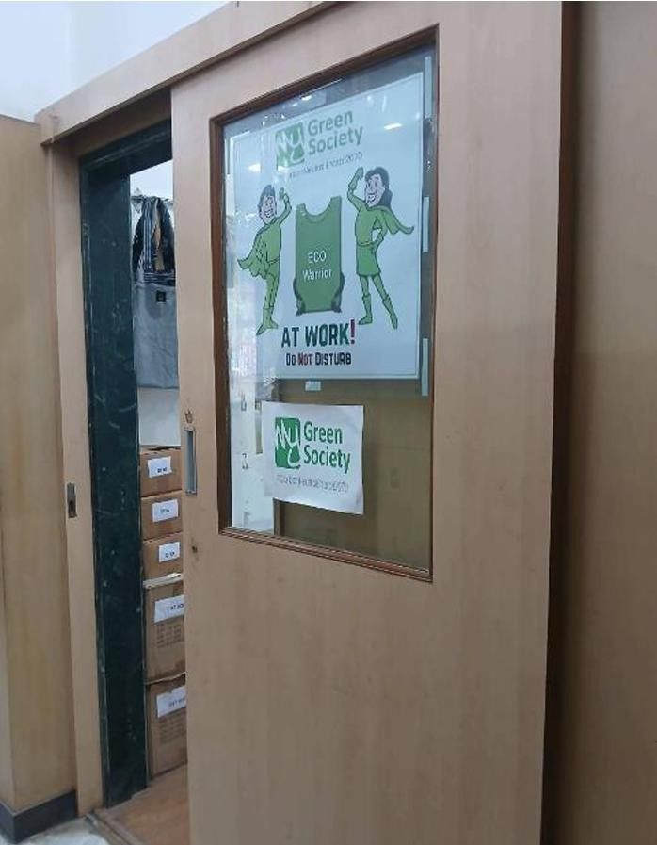
Figure 0.1

- Figure Reference: Figure 0.1 — Entrance and Workspace View of My Green Society.
- On-Site Observation: Illustrates the physical office environment and operational setup during the field visit.
- Organizational Branding: Highlights the official signage and eco-friendly messaging displayed at the facility entrance.
- Field Documentation: Serves as visual documentation of the primary location where community composting initiatives and management workflows are coordinated.

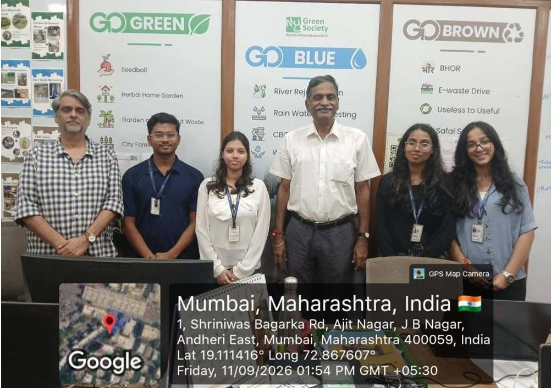
Figure 0.2

- Initial Project Scope & Setup Report
- Project Community Composting Management App
- Hosting Organization: My Green Society
- Overview: This report shows the steps and the building blocks of the Community Composting Management App. It covers the planning of user roles (Resident, Worker, Admin/NGO) the check of system needs and the design of the structure that will help Community Composting Management App track waste in the community and run composting activities smoothly.
- Objective: The goal is to build a digital system that brings together community people makes waste pickup schedules better watches composting units and encourages people to keep our environment clean and green.

Annexure B

- Survey Questionnaire / Interview Questions

  - How often do you separate your household waste into dry waste?
  - Do you know about the community composting programs run by My Green Society?
  - How useful would a mobile app be for getting reminders about waste collection schedules?
  - What problems do you face now with the timing of waste collection or disposal?
  - Would features such as Green Points. Rewards encourage you to get involved more, in waste management?
  - What projects have you worked on?
  - What internship opportunity does your organization offer to students?
  - Do you provide certification upon completion of the internship?

Annexure C

- Additional Interview Questions

- How do waste collection workers track daily route completions and address missed pickups?
- What specific reporting features do administrators require to monitor community composting capacity efficiently?
- What additional resources would help community members better understand composting and sustainable practices?

Annexure D
The Community Composting Management App follows a role-based architecture that connects residents, waste collection workers and administrators through one platform. The Community Composting Management App uses a Flutter interface that feels friendly. All data lives in Firebase and Firebase provide storage for photos and documents. The Community Composting Management App also uses Google Maps to help locate places and plan routes. I think the Community Composting Management App keeps everyone on the page and makes composting easier.

Figure 0.3

Annexure E

- Sample Output Screenshots / User Interface Layouts
- Overview: representations of key screens, within the application.
- Key Interface Views:
- Resident Dashboard: Shows collection schedules, Green Points and the waste reporting form.
- Worker Portal: Shows assigned collection routes and options to update status.
- Admin/NGO Analytics Panel: Shows community waste trends, composting unit status and tools for reporting.

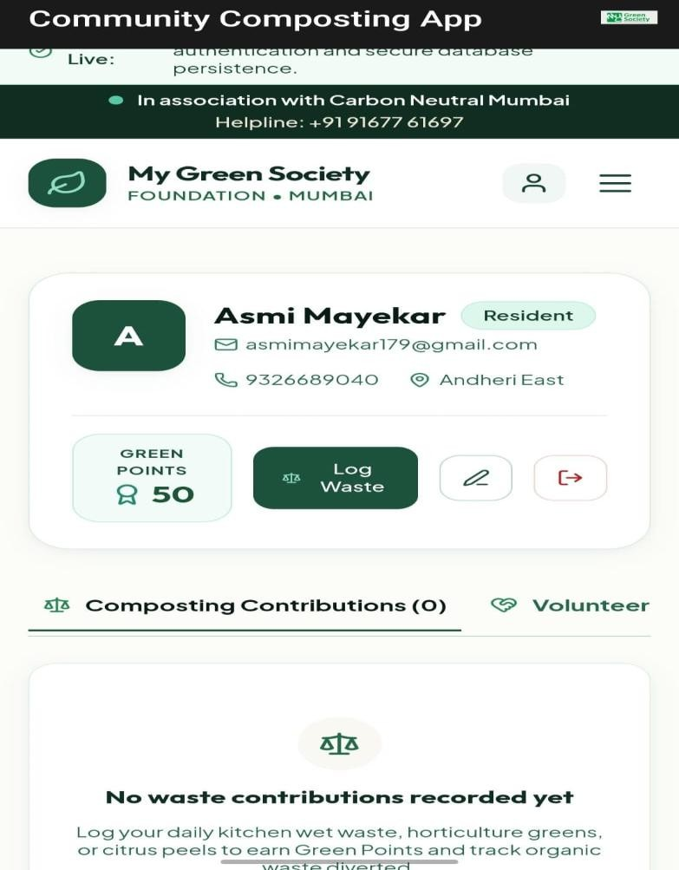
Figure 0.4

Annexure F

    - User Manual & Application Guide
    - Getting Started: When you open the application, you should log in with your assigned credentials or create a Resident account if you are a first-time user.
    - Residents: Residents can look at collection schedules keep track of waste contributions earn Green Points and report any collection issues through the app.
    - Workers: Workers have the ability to see their assigned collection routes update the status of each collection on a basis and record when a route is finished.
    - Admins / NGOs: Admins and NGOs can keep an eye on community composting units send out announcements manage profiles of all users and review reports, about the community.

Annexure G

- Source Code Directory & Local File Structure
  - Overview: The complete source code and project files for the Community Composting Management App are maintained locally and submitted via archive package / college portal.
  - Core File Directory & Architecture:
- /client or /frontend — Contains the user interface components, dashboards, and navigation layouts built for residents, workers, and admins.
- /server or /backend — Houses the API routes, server logic, and controller scripts handling waste logs and user data.
- /database — Includes database connection scripts, schemas, and operational data models.
- package. Json — Manages project dependencies, scripts, and runtime configurations.

